**CS5800 Theory Foundation**

**Report**

**Assignment 3**

**25)c)**

**INPUT NFA**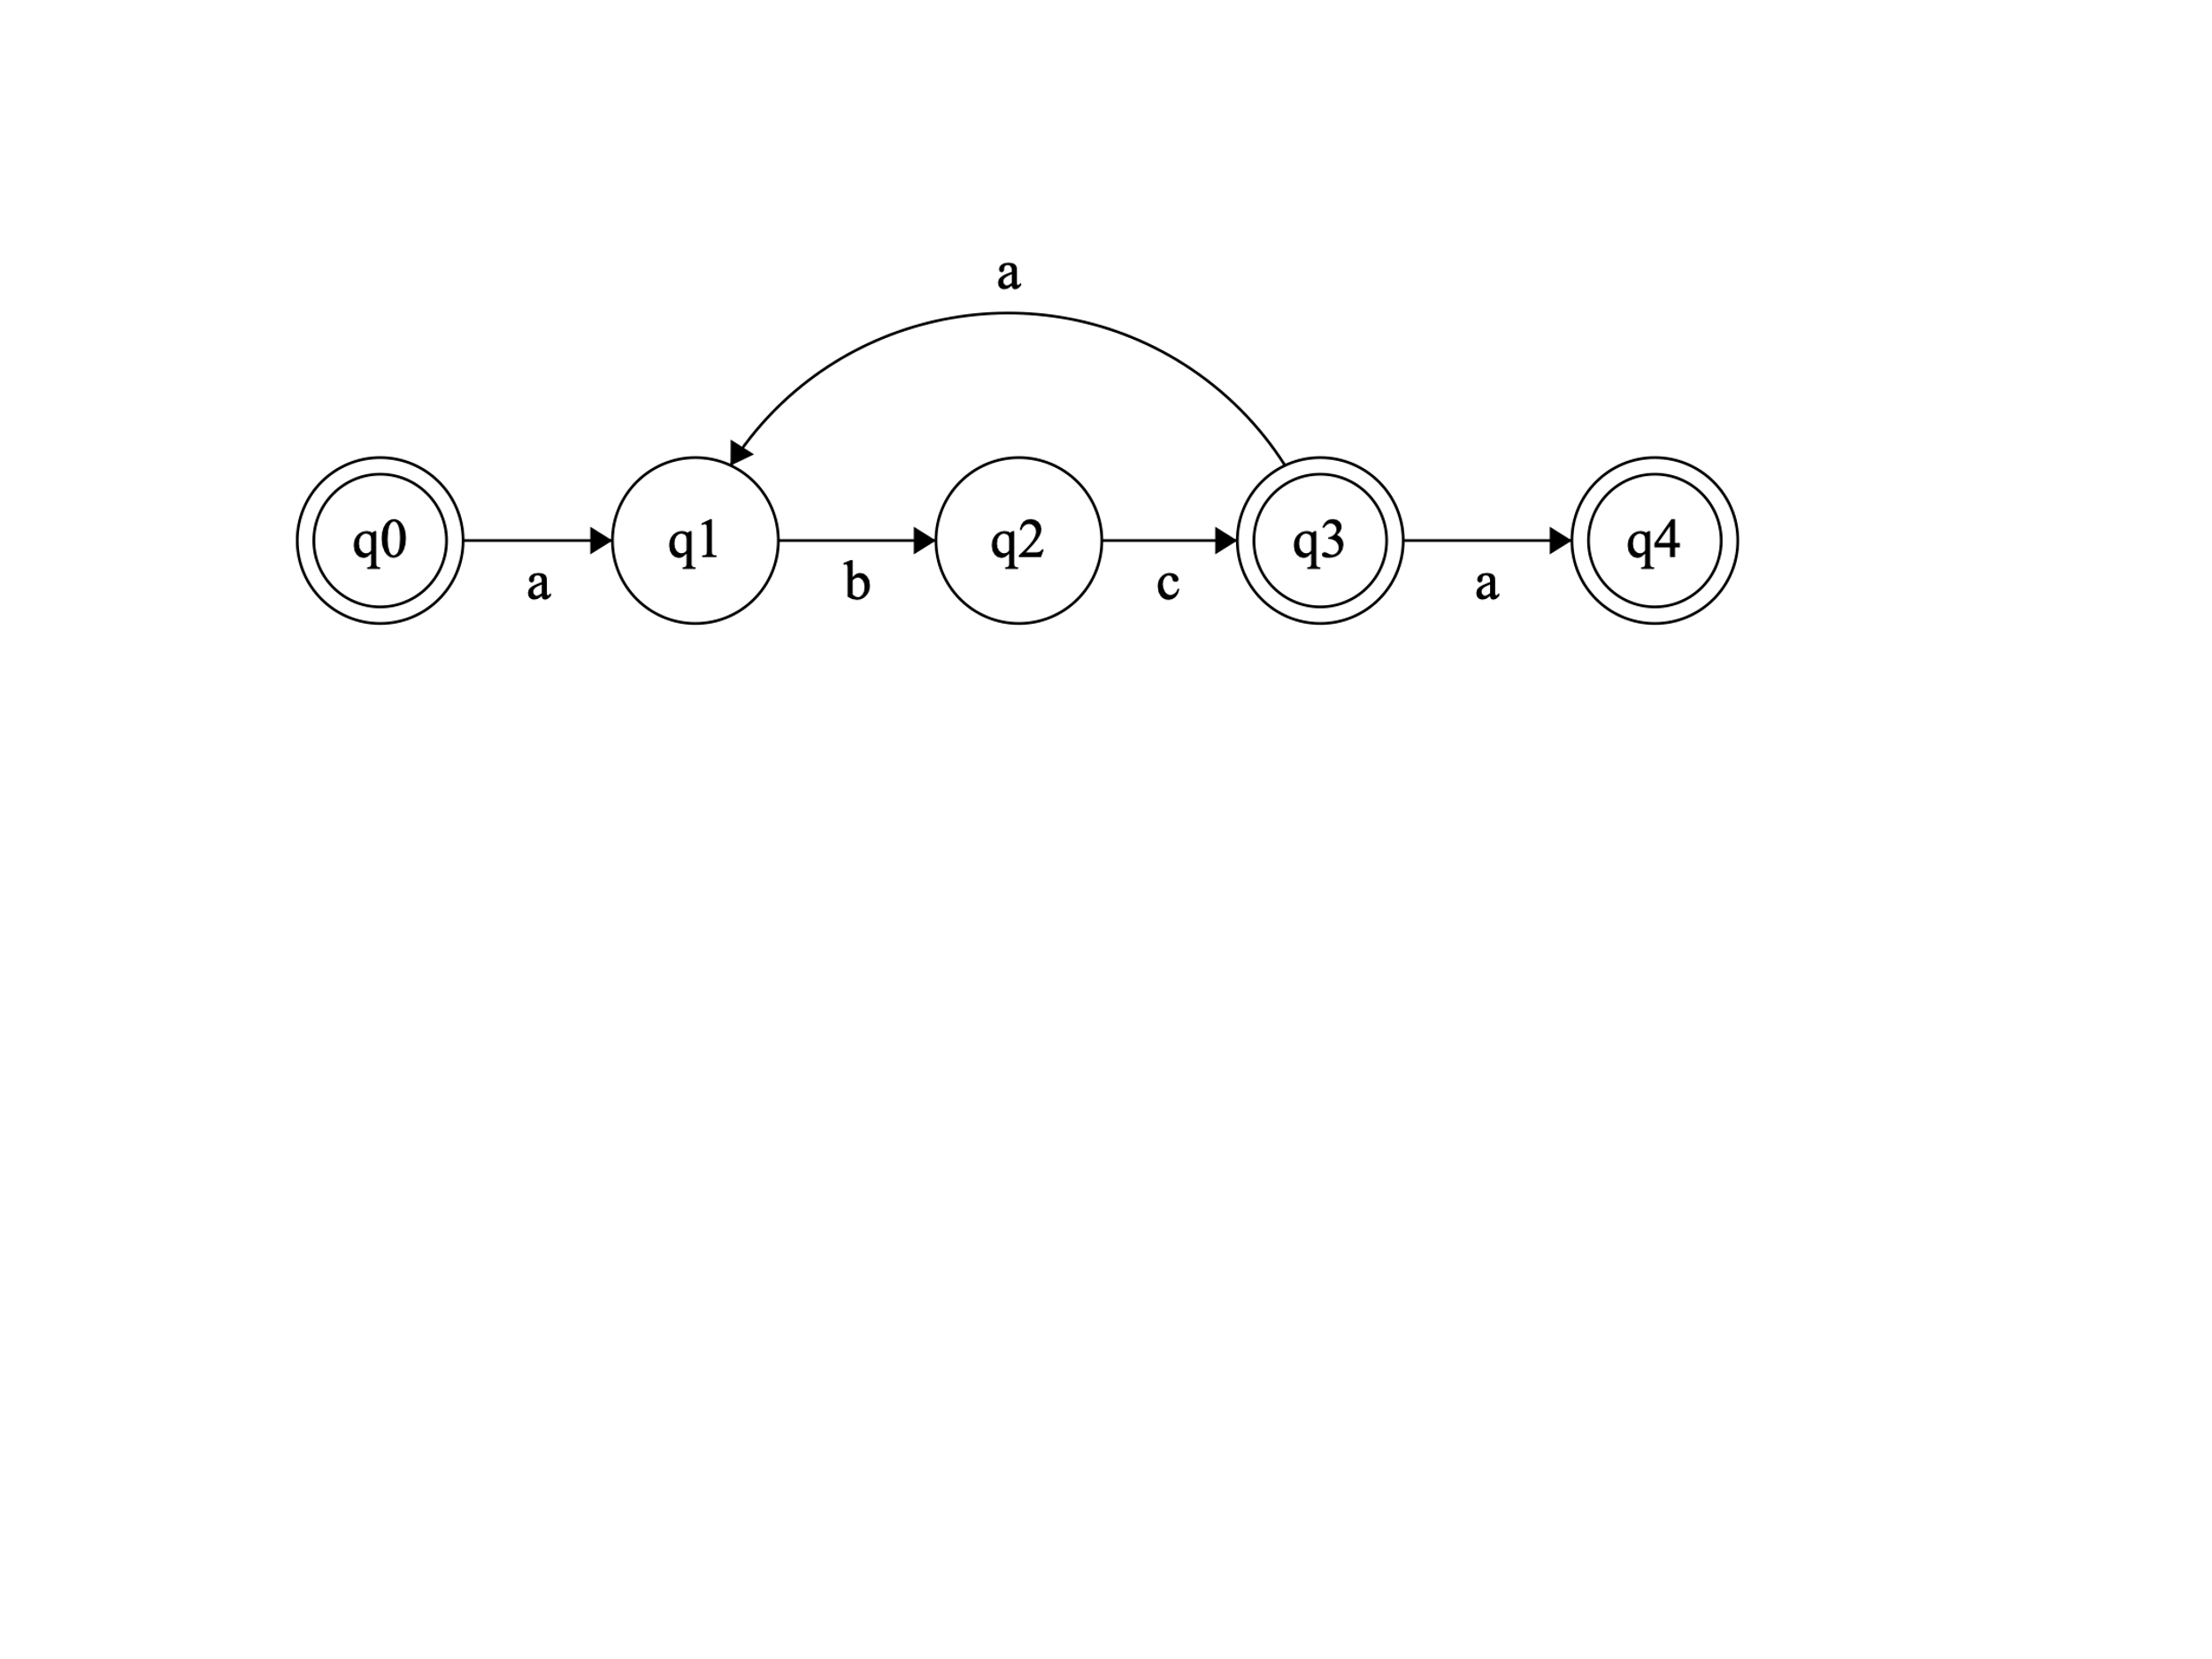

**Nfa-epsilon**

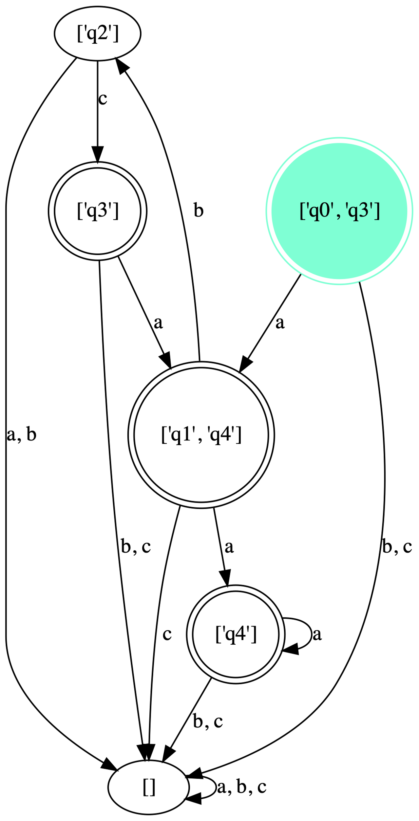

**DFA**

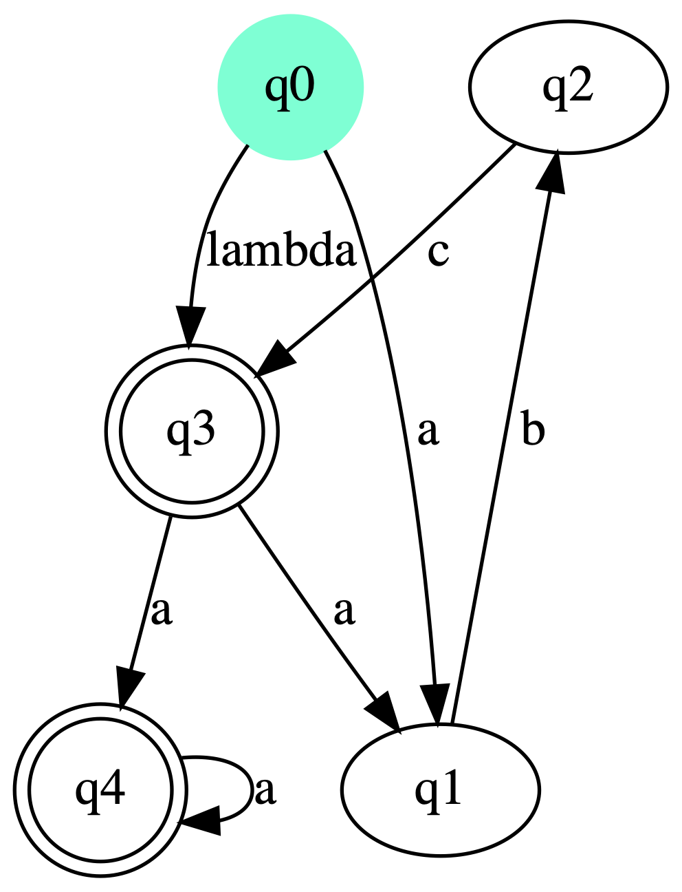

**Minimized DFA**

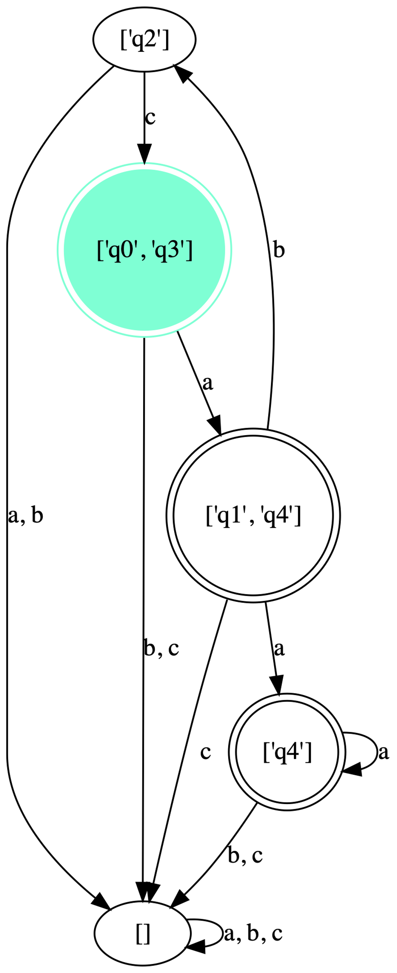

**25)d)**

**Input**

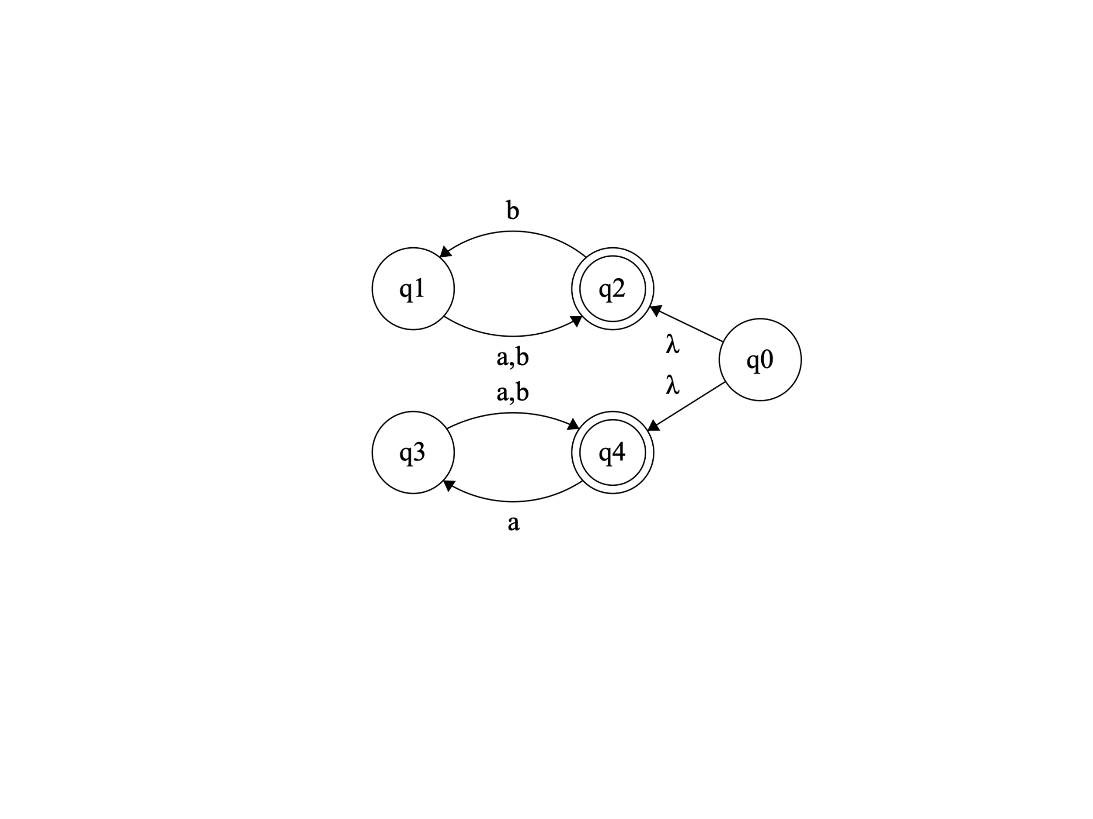

**NFA Epsilon**

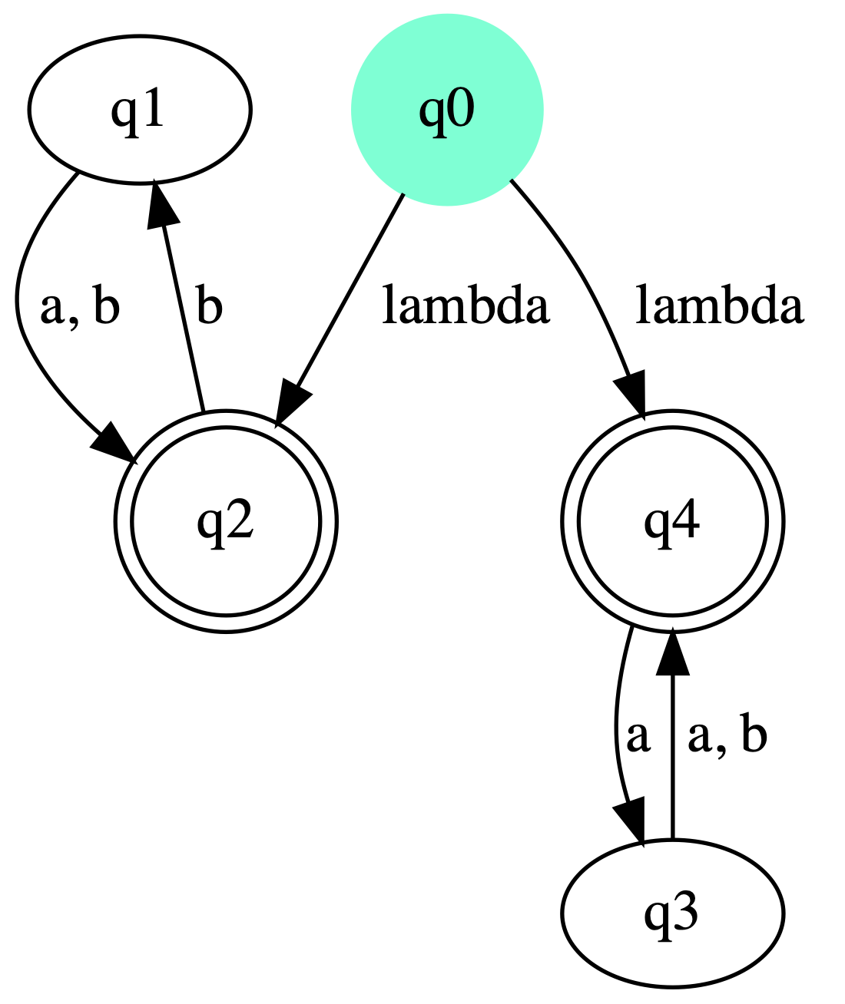

**DFA**

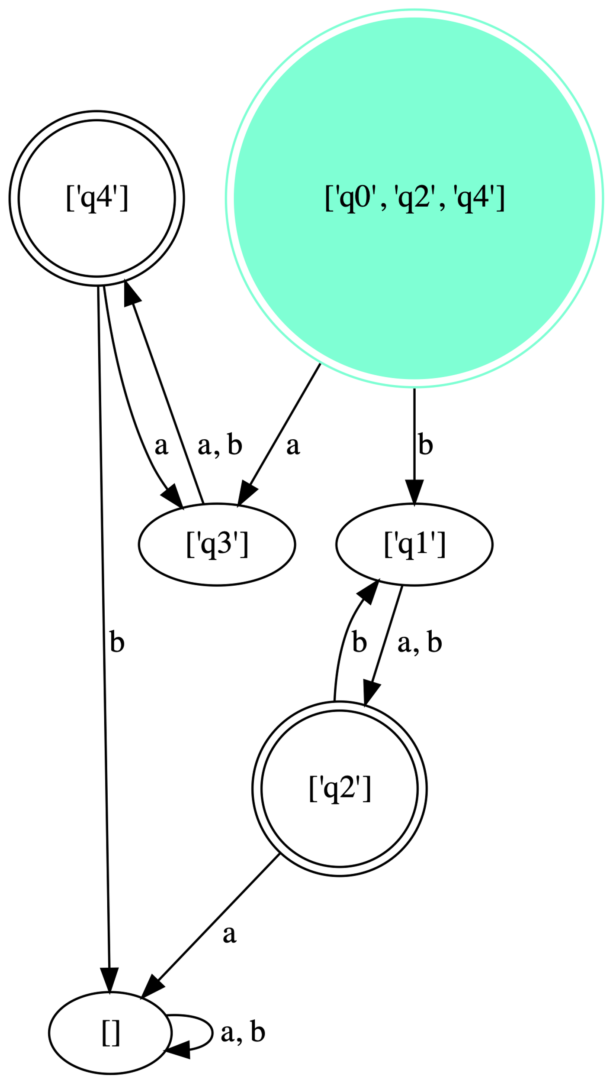

**DFA minimized**



**28)**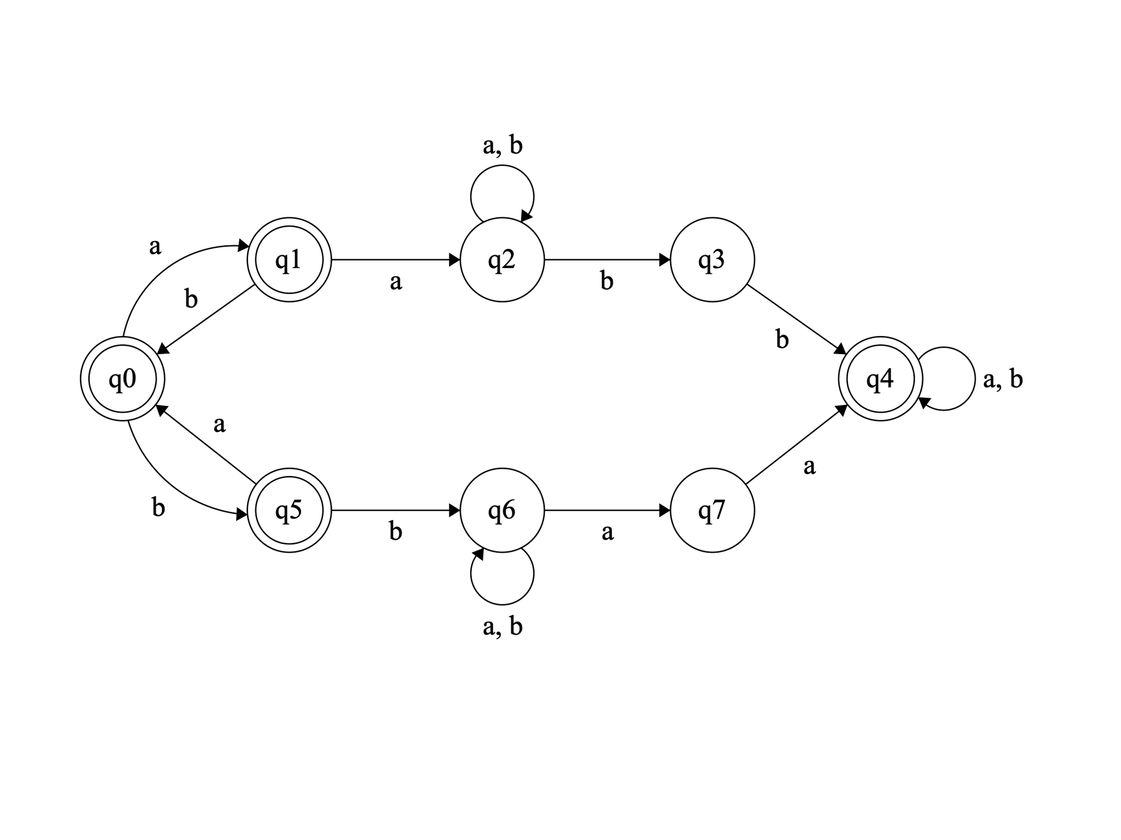

**NFA Epsilon**

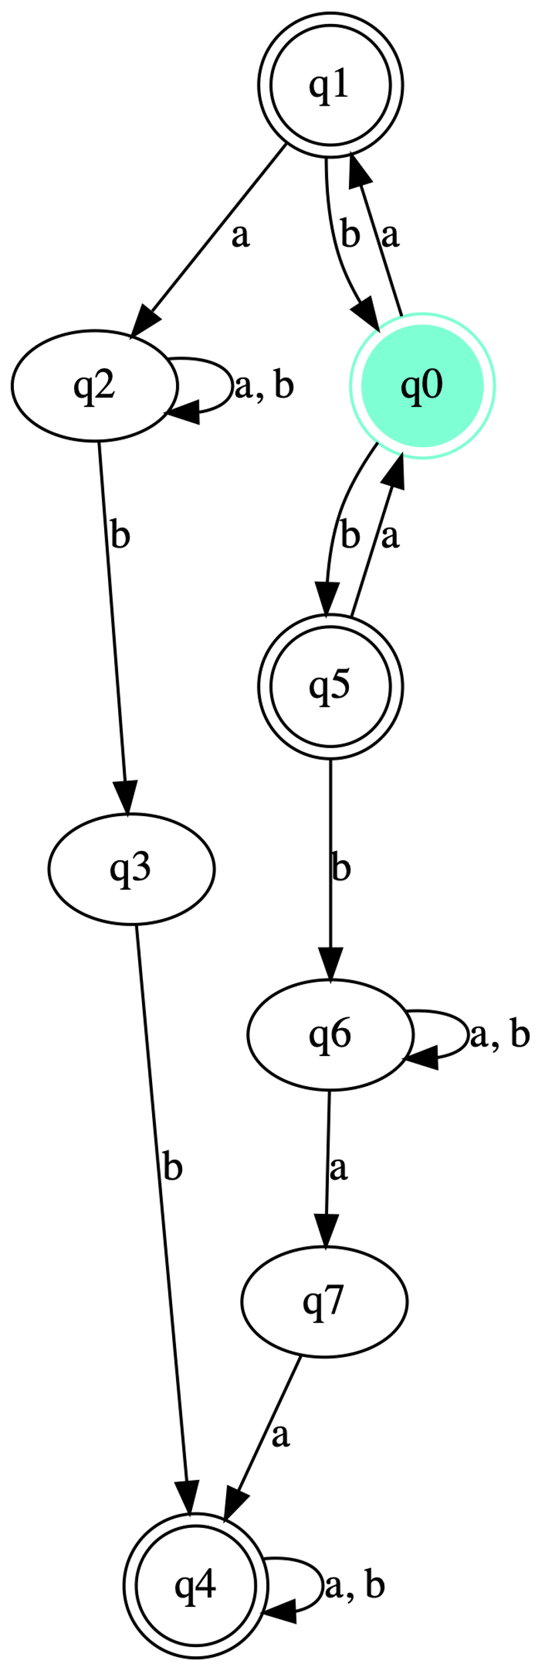

**DFA**

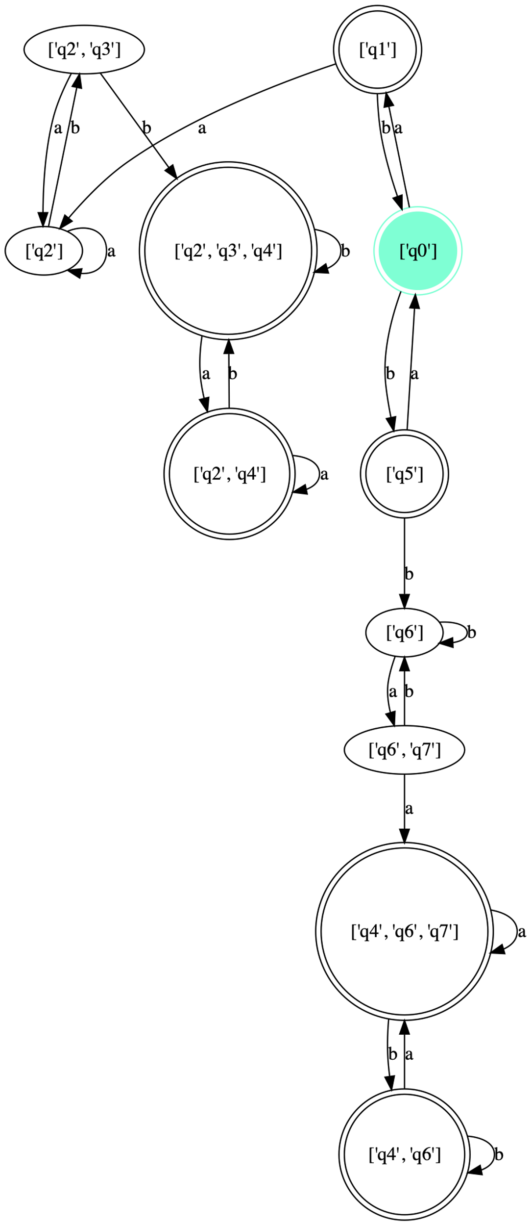

**DFA Minimized**

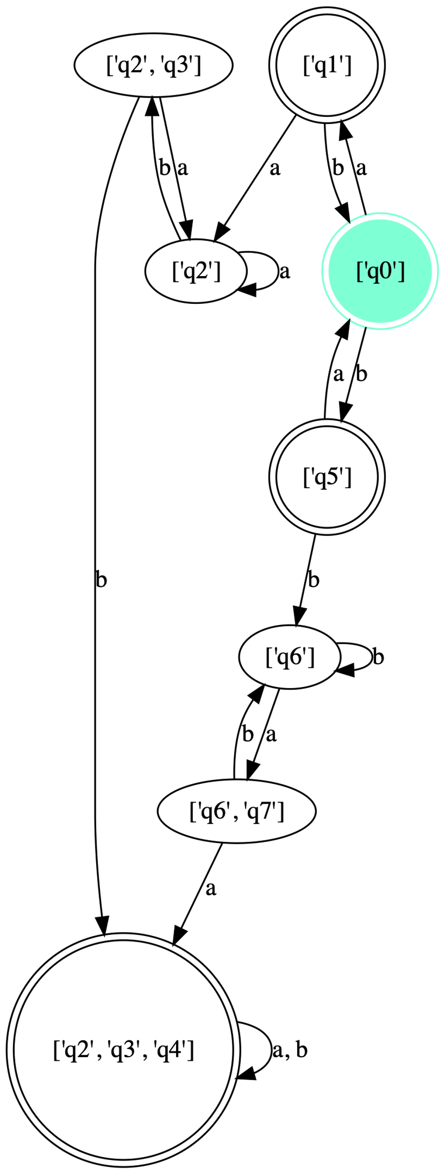

**29)** 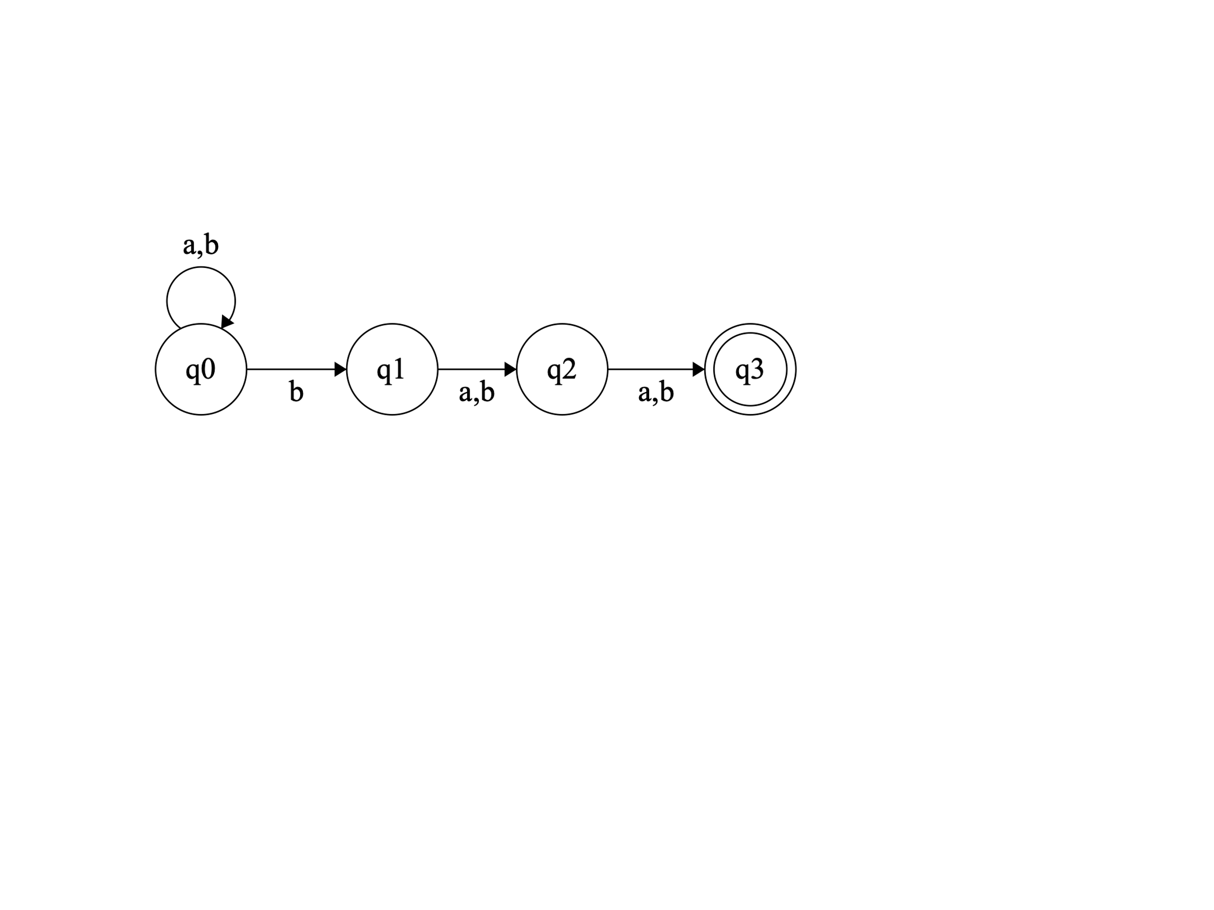

**NFA Epsilon**

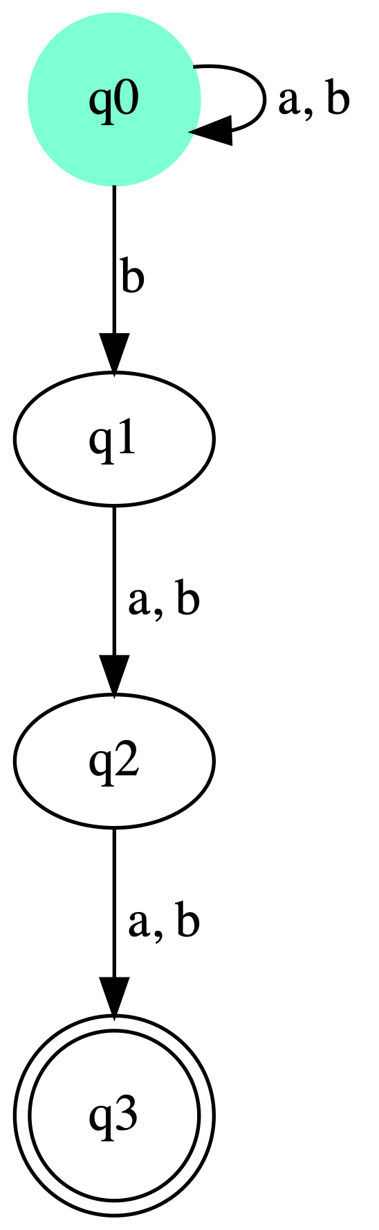

**DFA**

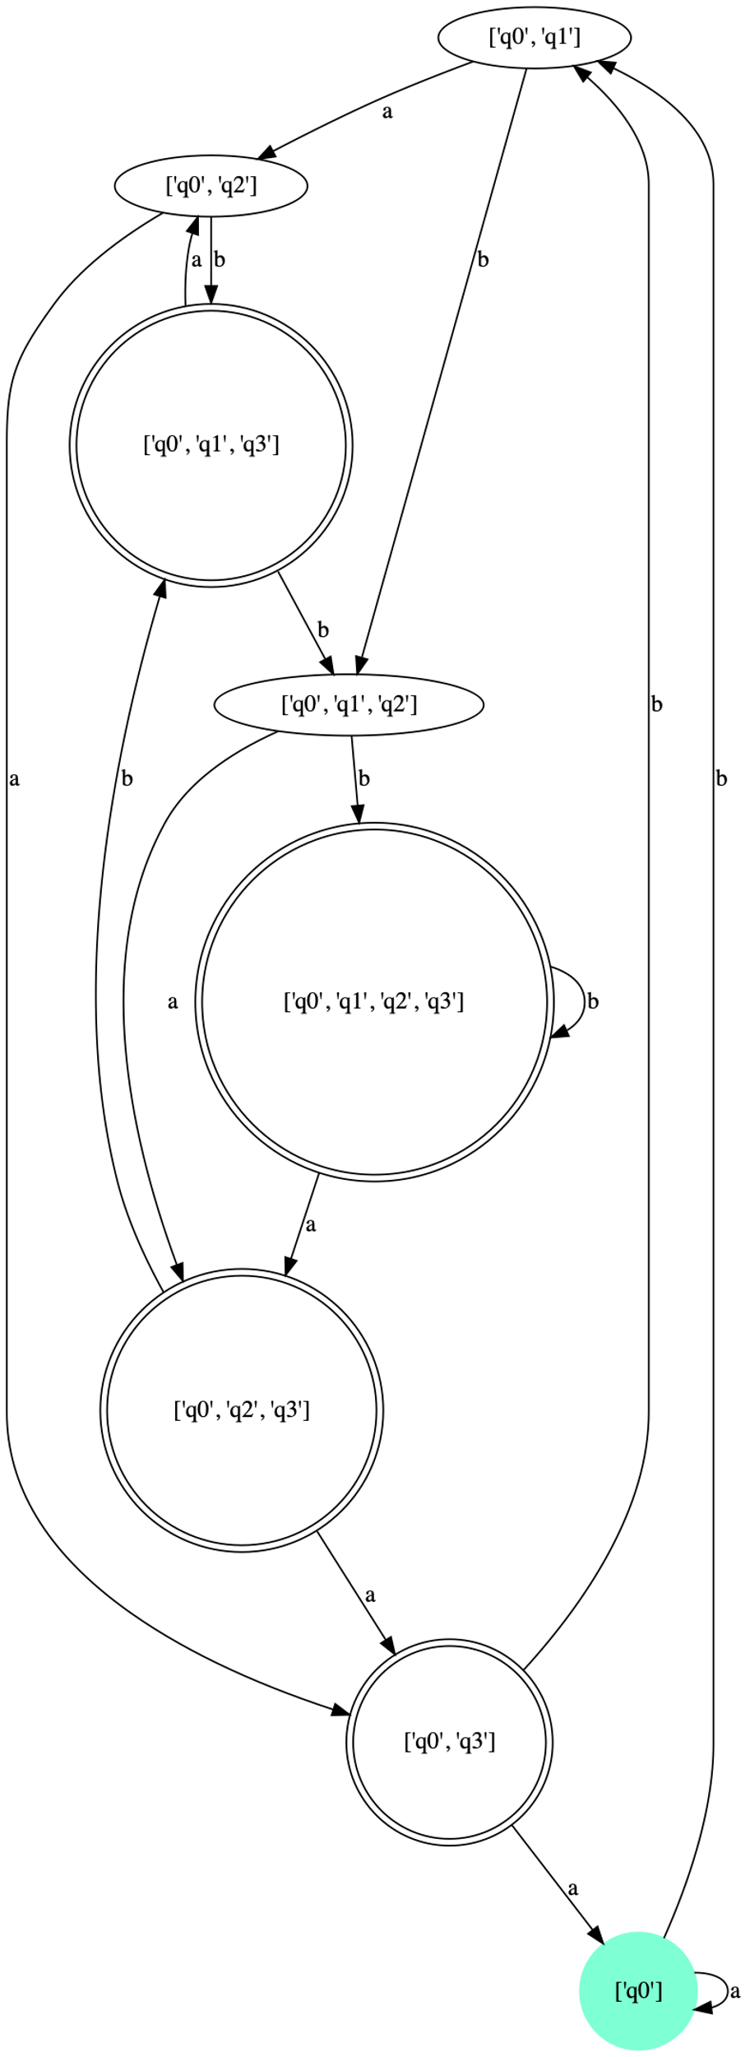

**DFA Minimized**



**25)c) OUTPUT**

*** Provided NFA

q: ['q0', 'q1', 'q2', 'q3', 'q4']

Sigma: {'a', 'c', 'b'}

q0: q0

F: ['q3', 'q4']

delta:

+-------+--------------+--------+--------+--------+

| delta | a | b | c | lambda |

+-------+--------------+--------+--------+--------+

| q0 | {'q1'} | | | {'q3'} |

| q1 | | {'q2'} | | |

| q2 | | | {'q3'} | |

| q3 | {'q1', 'q4'} | | | |

| q4 | {'q4'} | | | |

+-------+--------------+--------+--------+--------+

t-table:

+----+--------------+--------+--------+

| t | a | b | c |

+----+--------------+--------+--------+

| q0 | {'q1', 'q4'} | | |

| q1 | | {'q2'} | |

| q2 | | | {'q3'} |

| q3 | {'q1', 'q4'} | | |

| q4 | {'q4'} | | |

+----+--------------+--------+--------+

*** Converted DFA

q: ["['q0', 'q3']", "['q1', 'q4']", "['q2']", "['q3']", "['q4']", '[]']

Sigma: {'a', 'c', 'b'}

q0: ['q0', 'q3']

F: ["['q0', 'q3']", "['q1', 'q4']", "['q3']", "['q4']"]

delta:

+--------------+--------------+--------+--------+

| delta | a | b | c |

+--------------+--------------+--------+--------+

| ['q0', 'q3'] | ['q1', 'q4'] | [] | [] |

| ['q1', 'q4'] | ['q4'] | ['q2'] | [] |

| ['q2'] | [] | [] | ['q3'] |

| ['q3'] | ['q1', 'q4'] | [] | [] |

| ['q4'] | ['q4'] | [] | [] |

| [] | [] | [] | [] |

+--------------+--------------+--------+--------+

+++ Map of state number to state name serving as the legend in triangle:

0 | ['q0', 'q3']

1 | ['q1', 'q4']

2 | ['q2']

3 | ['q3']

4 | ['q4']

5 | []

+++ Marked all pairs of states where one is a final state, while the other is not

0

1 1

0 0 1

0 0 1 0

1 1 0 1 1

**-------**

+++ Triangle filled

3

1 1

0 3 1

4 3 1 4

1 1 2 1 1

**-------**

*** Minimized DFA

q: ["['q0', 'q3']", "['q1', 'q4']", "['q2']", "['q4']", '[]']

Sigma: {'a', 'c', 'b'}

q0: ['q0', 'q3']

F: ["['q0', 'q3']", "['q1', 'q4']", "['q4']"]

delta:

+--------------+--------------+--------+--------------+

| delta | a | b | c |

+--------------+--------------+--------+--------------+

| ['q0', 'q3'] | ['q1', 'q4'] | [] | [] |

| ['q1', 'q4'] | ['q4'] | ['q2'] | [] |

| ['q2'] | [] | [] | ['q0', 'q3'] |

| ['q4'] | ['q4'] | [] | [] |

| [] | [] | [] | [] |

+--------------+--------------+--------+--------------+

Input string: abcabcaa

['q0', 'q3'] -- a --> ['q1', 'q4'] -- b --> ['q2'] -- c --> ['q0', 'q3'] -- a --> ['q1', 'q4'] -- b --> ['q2'] -- c --> ['q0', 'q3'] -- a --> ['q1', 'q4'] -- a --> ['q4'] ACCEPT

Input string: abcaca

['q0', 'q3'] -- a --> ['q1', 'q4'] -- b --> ['q2'] -- c --> ['q0', 'q3'] -- a --> ['q1', 'q4'] -- c --> [] -- a --> [] REJECT

**25)d) OUTPUT**

*** Provided NFA

q: ['q0', 'q1', 'q2', 'q3', 'q4']

Sigma: {'a', 'b'}

q0: q0

F: ['q2', 'q4']

delta:

+-------+--------+--------+--------------+

| delta | a | b | lambda |

+-------+--------+--------+--------------+

| q0 | | | {'q4', 'q2'} |

| q1 | {'q2'} | {'q2'} | |

| q2 | | {'q1'} | |

| q3 | {'q4'} | {'q4'} | |

| q4 | {'q3'} | | |

+-------+--------+--------+--------------+

t-table:

+----+--------+--------+

| t | a | b |

+----+--------+--------+

| q0 | {'q3'} | {'q1'} |

| q1 | {'q2'} | {'q2'} |

| q2 | | {'q1'} |

| q3 | {'q4'} | {'q4'} |

| q4 | {'q3'} | |

+----+--------+--------+

*** Converted DFA

q: ["['q0', 'q2', 'q4']", "['q1']", "['q2']", "['q3']", "['q4']", '[]']

Sigma: {'a', 'b'}

q0: ['q0', 'q2', 'q4']

F: ["['q0', 'q2', 'q4']", "['q2']", "['q4']"]

delta:

+--------------------+--------+--------+

| delta | a | b |

+--------------------+--------+--------+

| ['q0', 'q2', 'q4'] | ['q3'] | ['q1'] |

| ['q1'] | ['q2'] | ['q2'] |

| ['q2'] | [] | ['q1'] |

| ['q3'] | ['q4'] | ['q4'] |

| ['q4'] | ['q3'] | [] |

| [] | [] | [] |

+--------------------+--------+--------+

+++ Map of state number to state name serving as the legend in triangle:

0 | ['q0', 'q2', 'q4']

1 | ['q1']

2 | ['q2']

3 | ['q3']

4 | ['q4']

5 | []

+++ Marked all pairs of states where one is a final state, while the other is not

1

0 1

1 0 1

0 1 0 1

1 0 1 0 1

**-------**

+++ Triangle filled

1

3 1

1 4 1

3 1 3 1

1 2 1 2 1

**-------**

*** Minimized DFA

q: ["['q0', 'q2', 'q4']", "['q1']", "['q2']", "['q3']", "['q4']", '[]']

Sigma: {'a', 'b'}

q0: ['q0', 'q2', 'q4']

F: ["['q0', 'q2', 'q4']", "['q2']", "['q4']"]

delta:

+--------------------+--------+--------+

| delta | a | b |

+--------------------+--------+--------+

| ['q0', 'q2', 'q4'] | ['q3'] | ['q1'] |

| ['q1'] | ['q2'] | ['q2'] |

| ['q2'] | [] | ['q1'] |

| ['q3'] | ['q4'] | ['q4'] |

| ['q4'] | ['q3'] | [] |

| [] | [] | [] |

+--------------------+--------+--------+

Input string: babbbb

['q0', 'q2', 'q4'] -- b --> ['q1'] -- a --> ['q2'] -- b --> ['q1'] -- b --> ['q2'] -- b --> ['q1'] -- b --> ['q2'] ACCEPT

Input string: abba

['q0', 'q2', 'q4'] -- a --> ['q3'] -- b --> ['q4'] -- b --> [] -- a --> [] REJECT

**28) OUTPUT**

*** Provided NFA

q: ['q0', 'q1', 'q2', 'q3', 'q4', 'q5', 'q6', 'q7']

Sigma: {'a', 'b'}

q0: q0

F: ['q0', 'q1', 'q4', 'q5']

delta:

+-------+--------------+--------------+--------+

| delta | a | b | lambda |

+-------+--------------+--------------+--------+

| q0 | {'q1'} | {'q5'} | |

| q1 | {'q2'} | {'q0'} | |

| q2 | {'q2'} | {'q2', 'q3'} | |

| q3 | | {'q4'} | |

| q4 | {'q4'} | {'q4'} | |

| q5 | {'q0'} | {'q6'} | |

| q6 | {'q7', 'q6'} | {'q6'} | |

| q7 | {'q4'} | | |

+-------+--------------+--------------+--------+

t-table:

+----+--------------+--------------+

| t | a | b |

+----+--------------+--------------+

| q0 | {'q1'} | {'q5'} |

| q1 | {'q2'} | {'q0'} |

| q2 | {'q2'} | {'q2', 'q3'} |

| q3 | | {'q4'} |

| q4 | {'q4'} | {'q4'} |

| q5 | {'q0'} | {'q6'} |

| q6 | {'q7', 'q6'} | {'q6'} |

| q7 | {'q4'} | |

+----+--------------+--------------+

*** Converted DFA

q: ["['q0']", "['q1']", "['q2', 'q3', 'q4']", "['q2', 'q3']", "['q2', 'q4']", "['q2']", "['q4', 'q6', 'q7']", "['q4', 'q6']", "['q5']", "['q6', 'q7']", "['q6']"]

Sigma: {'a', 'b'}

q0: ['q0']

F: ["['q0']", "['q1']", "['q2', 'q3', 'q4']", "['q2', 'q4']", "['q4', 'q6', 'q7']", "['q4', 'q6']", "['q5']"]

delta:

+--------------------+--------------------+--------------------+

| delta | a | b |

+--------------------+--------------------+--------------------+

| ['q0'] | ['q1'] | ['q5'] |

| ['q1'] | ['q2'] | ['q0'] |

| ['q2', 'q3', 'q4'] | ['q2', 'q4'] | ['q2', 'q3', 'q4'] |

| ['q2', 'q3'] | ['q2'] | ['q2', 'q3', 'q4'] |

| ['q2', 'q4'] | ['q2', 'q4'] | ['q2', 'q3', 'q4'] |

| ['q2'] | ['q2'] | ['q2', 'q3'] |

| ['q4', 'q6', 'q7'] | ['q4', 'q6', 'q7'] | ['q4', 'q6'] |

| ['q4', 'q6'] | ['q4', 'q6', 'q7'] | ['q4', 'q6'] |

| ['q5'] | ['q0'] | ['q6'] |

| ['q6', 'q7'] | ['q4', 'q6', 'q7'] | ['q6'] |

| ['q6'] | ['q6', 'q7'] | ['q6'] |

+--------------------+--------------------+--------------------+

+++ Map of state number to state name serving as the legend in triangle:

0 | ['q0']

1 | ['q1']

2 | ['q2', 'q3', 'q4']

3 | ['q2', 'q3']

4 | ['q2', 'q4']

5 | ['q2']

6 | ['q4', 'q6', 'q7']

7 | ['q4', 'q6']

8 | ['q5']

9 | ['q6', 'q7']

10 | ['q6']

+++ Marked all pairs of states where one is a final state, while the other is not

0

0 0

1 1 1

0 0 0 1

1 1 1 0 1

0 0 0 1 0 1

0 0 0 1 0 1 0

0 0 0 1 0 1 0 0

1 1 1 0 1 0 1 1 1

1 1 1 0 1 0 1 1 1 0

**-------**

+++ Triangle filled

2

3 2

1 1 1

3 2 0 1

1 1 1 2 1

3 2 0 1 0 1

3 2 0 1 0 1 0

2 2 2 1 2 1 2 2

1 1 1 2 1 2 1 1 1

1 1 1 2 1 3 1 1 1 2

**-------**

*** Minimized DFA

q: ["['q0']", "['q1']", "['q2', 'q3', 'q4']", "['q2', 'q3']", "['q2']", "['q5']", "['q6', 'q7']", "['q6']"]

Sigma: {'a', 'b'}

q0: ['q0']

F: ["['q0']", "['q1']", "['q2', 'q3', 'q4']", "['q5']"]

delta:

+--------------------+--------------------+--------------------+

| delta | a | b |

+--------------------+--------------------+--------------------+

| ['q0'] | ['q1'] | ['q5'] |

| ['q1'] | ['q2'] | ['q0'] |

| ['q2', 'q3', 'q4'] | ['q2', 'q3', 'q4'] | ['q2', 'q3', 'q4'] |

| ['q2', 'q3'] | ['q2'] | ['q2', 'q3', 'q4'] |

| ['q2'] | ['q2'] | ['q2', 'q3'] |

| ['q5'] | ['q0'] | ['q6'] |

| ['q6', 'q7'] | ['q2', 'q3', 'q4'] | ['q6'] |

| ['q6'] | ['q6', 'q7'] | ['q6'] |

+--------------------+--------------------+--------------------+

Input string: aaaababb

['q0'] -- a --> ['q1'] -- a --> ['q2'] -- a --> ['q2'] -- a --> ['q2'] -- b --> ['q2', 'q3'] -- a --> ['q2'] -- b --> ['q2', 'q3'] -- b --> ['q2', 'q3', 'q4'] ACCEPT

Input string: aaaabab

['q0'] -- a --> ['q1'] -- a --> ['q2'] -- a --> ['q2'] -- a --> ['q2'] -- b --> ['q2', 'q3'] -- a --> ['q2'] -- b --> ['q2', 'q3'] REJECT

**29)OUTPUT**

*** Provided NFA

q: ['q0', 'q1', 'q2', 'q3']

Sigma: {'b', 'a'}

q0: q0

F: ['q3']

delta:

+-------+--------+--------------+--------+

| delta | a | b | lambda |

+-------+--------+--------------+--------+

| q0 | {'q0'} | {'q1', 'q0'} | |

| q1 | {'q2'} | {'q2'} | |

| q2 | {'q3'} | {'q3'} | |

| q3 | | | |

+-------+--------+--------------+--------+

t-table:

+----+--------+--------------+

| t | a | b |

+----+--------+--------------+

| q0 | {'q0'} | {'q1', 'q0'} |

| q1 | {'q2'} | {'q2'} |

| q2 | {'q3'} | {'q3'} |

| q3 | | |

+----+--------+--------------+

*** Converted DFA

q: ["['q0', 'q1', 'q2', 'q3']", "['q0', 'q1', 'q2']", "['q0', 'q1', 'q3']", "['q0', 'q1']", "['q0', 'q2', 'q3']", "['q0', 'q2']", "['q0', 'q3']", "['q0']"]

Sigma: {'b', 'a'}

q0: ['q0']

F: ["['q0', 'q1', 'q2', 'q3']", "['q0', 'q1', 'q3']", "['q0', 'q2', 'q3']", "['q0', 'q3']"]

delta:

+--------------------------+--------------------+--------------------------+

| delta | a | b |

+--------------------------+--------------------+--------------------------+

| ['q0', 'q1', 'q2', 'q3'] | ['q0', 'q2', 'q3'] | ['q0', 'q1', 'q2', 'q3'] |

| ['q0', 'q1', 'q2'] | ['q0', 'q2', 'q3'] | ['q0', 'q1', 'q2', 'q3'] |

| ['q0', 'q1', 'q3'] | ['q0', 'q2'] | ['q0', 'q1', 'q2'] |

| ['q0', 'q1'] | ['q0', 'q2'] | ['q0', 'q1', 'q2'] |

| ['q0', 'q2', 'q3'] | ['q0', 'q3'] | ['q0', 'q1', 'q3'] |

| ['q0', 'q2'] | ['q0', 'q3'] | ['q0', 'q1', 'q3'] |

| ['q0', 'q3'] | ['q0'] | ['q0', 'q1'] |

| ['q0'] | ['q0'] | ['q0', 'q1'] |

+--------------------------+--------------------+--------------------------+

+++ Map of state number to state name serving as the legend in triangle:

0 | ['q0', 'q1', 'q2', 'q3']

1 | ['q0', 'q1', 'q2']

2 | ['q0', 'q1', 'q3']

3 | ['q0', 'q1']

4 | ['q0', 'q2', 'q3']

5 | ['q0', 'q2']

6 | ['q0', 'q3']

7 | ['q0']

+++ Marked all pairs of states where one is a final state, while the other is not

1

0 1

1 0 1

0 1 0 1

1 0 1 0 1

0 1 0 1 0 1

1 0 1 0 1 0 1

**-------**

+++ Triangle filled

1

2 1

1 2 1

3 1 2 1

1 3 1 2 1

2 1 3 1 2 1

1 2 1 3 1 2 1

**-------**

*** Minimized DFA

q: ["['q0', 'q1', 'q2', 'q3']", "['q0', 'q1', 'q2']", "['q0', 'q1', 'q3']", "['q0', 'q1']", "['q0', 'q2', 'q3']", "['q0', 'q2']", "['q0', 'q3']", "['q0']"]

Sigma: {'b', 'a'}

q0: ['q0']

F: ["['q0', 'q1', 'q2', 'q3']", "['q0', 'q1', 'q3']", "['q0', 'q2', 'q3']", "['q0', 'q3']"]

delta:

+--------------------------+--------------------+--------------------------+

| delta | a | b |

+--------------------------+--------------------+--------------------------+

| ['q0', 'q1', 'q2', 'q3'] | ['q0', 'q2', 'q3'] | ['q0', 'q1', 'q2', 'q3'] |

| ['q0', 'q1', 'q2'] | ['q0', 'q2', 'q3'] | ['q0', 'q1', 'q2', 'q3'] |

| ['q0', 'q1', 'q3'] | ['q0', 'q2'] | ['q0', 'q1', 'q2'] |

| ['q0', 'q1'] | ['q0', 'q2'] | ['q0', 'q1', 'q2'] |

| ['q0', 'q2', 'q3'] | ['q0', 'q3'] | ['q0', 'q1', 'q3'] |

| ['q0', 'q2'] | ['q0', 'q3'] | ['q0', 'q1', 'q3'] |

| ['q0', 'q3'] | ['q0'] | ['q0', 'q1'] |

| ['q0'] | ['q0'] | ['q0', 'q1'] |

+--------------------------+--------------------+--------------------------+

Input string: bbbaa

['q0'] -- b --> ['q0', 'q1'] -- b --> ['q0', 'q1', 'q2'] -- b --> ['q0', 'q1', 'q2', 'q3'] -- a --> ['q0', 'q2', 'q3'] -- a --> ['q0', 'q3'] ACCEPT

Input string: aba

['q0'] -- a --> ['q0'] -- b --> ['q0', 'q1'] -- a --> ['q0', 'q2'] REJECT